Area Setup and Calibration
When setting up the Oculus headset for use with each user it will likely be necessary to reset the play area. During this process it is important to also check the battery status of each controller. Be sure to replace the battery around 20%.
- Have each Oculus station positioned at least 6 feet from one another.
- Have the user stand in front of the station then open the OMS client. Login to OMS and return to the desktop. Next, look for and open the Oculus client on the computer. It will be located on the desktop and look similar to this.
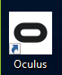

- From the Oculus home screen, click devices circled in red.
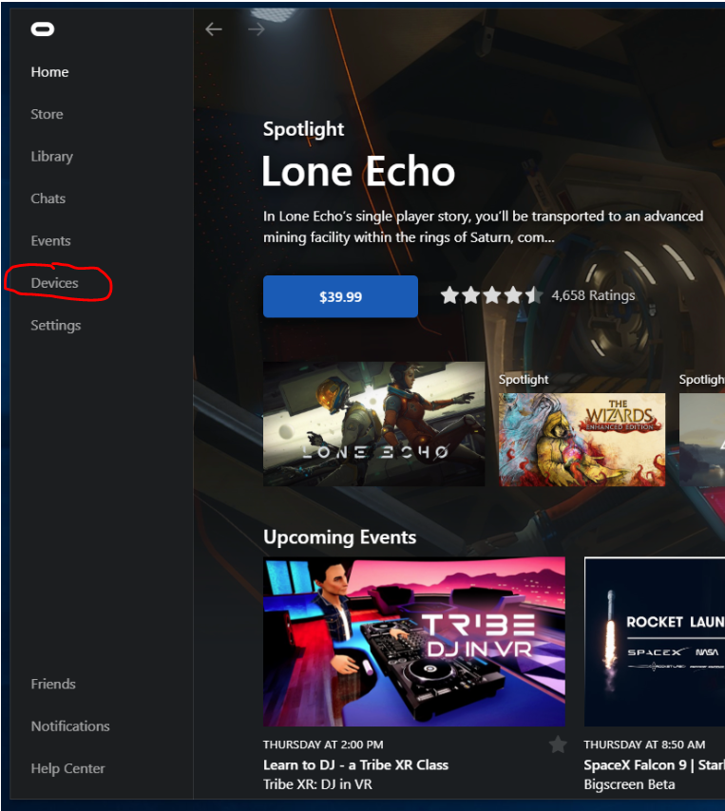

- On this new screen note the area circled in blue. If the battery for either controller is low replace before continuing. The controller should automatically turn on. After checking the battery click the arrow in the area circled in red.
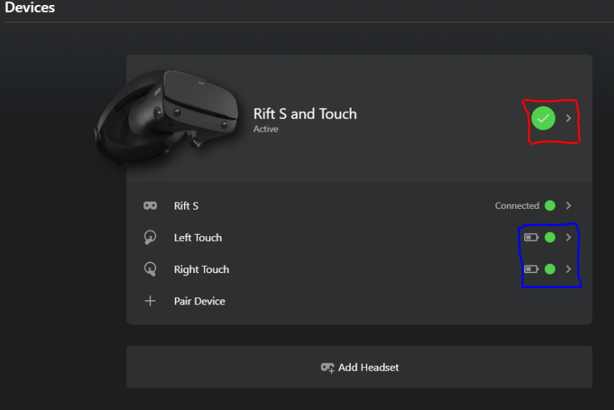

- From this screen it may be necessary to scroll down and click on Guardian Setup circled in red.
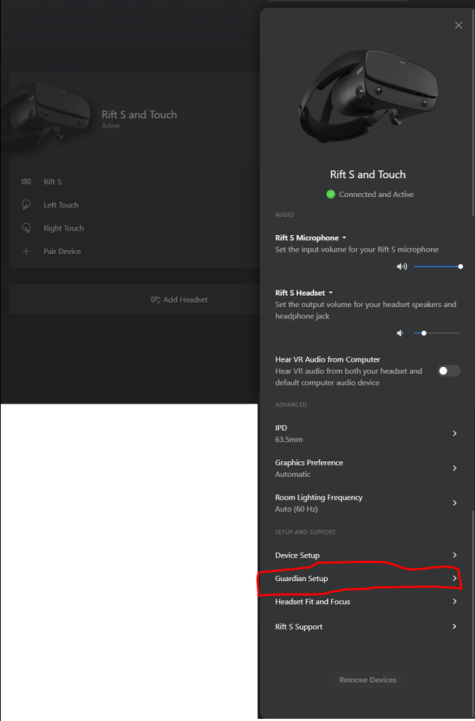
- You will see this menu. At this point, stand roughly 3 feet in front of the VR station, put the headset on and grab both controllers. You will continue to follow the instructions displayed on the headset to setup your play area. Signal your instructor to launch the designated scenario. If you happen to move too far from the area or take a break and come back – place the headset on and look for the grey circle on the ground. Stand on it to have the play area reappear.

